Numerical Feature Transformations — Starbucks Customers
1-Page Summary Report | Extended Project
Problem Statement
Machine-learning models (logistic regression, neural nets, KNN, regularized linear models, PCA, clustering) treat features on different scales or with heavy skew unequally. The Starbucks customer survey (n=122) contains numerical features—spent, nearest_starbucks, age, and 1–5 ratings—that differ in units and distribution. Without transformation, distance-based algorithms and gradient-based optimizers can be dominated by high-magnitude or skewed variables, reducing accuracy and interpretability.
Solution Strategy
Apply a systematic numerical-transformation pipeline: (1) diagnose with .describe(), skew, and histograms; (2) center (subtract mean) for interpretability of deviations; (3) standardize (z-score / StandardScaler) for equal-variance features required by PCA/KNN/regularization; (4) min-max scale to [0,1] when bounded inputs are preferred (neural nets); (5) log1p transform right-skewed positive variables (age, spent); (6) optional quantile/equal-width binning to capture non-linear effects. Provide both pure-NumPy/pandas and sklearn implementations plus a Monte-Carlo simulation of transform impact on a simple linear model.
Solution
Key results on Starbucks data:
- Age (mean ≈ 27.3, skew ≈ 1.76) → after centering mean = 0; after StandardScaler μ≈0, σ≈1.
- Spent (0–28) → MinMaxScaler maps cleanly to [0,1]; log1p reduces mild right skew and stabilizes variance.
- nearest_starbucks (0–8) benefits from both standardization and binning (near / medium / far).
- Simulation (80 bootstrap + noise runs): log(age)+StandardScaler yielded the highest average in-sample R² when predicting spent from age + distance + average rating, illustrating the practical value of skew correction before scaling.
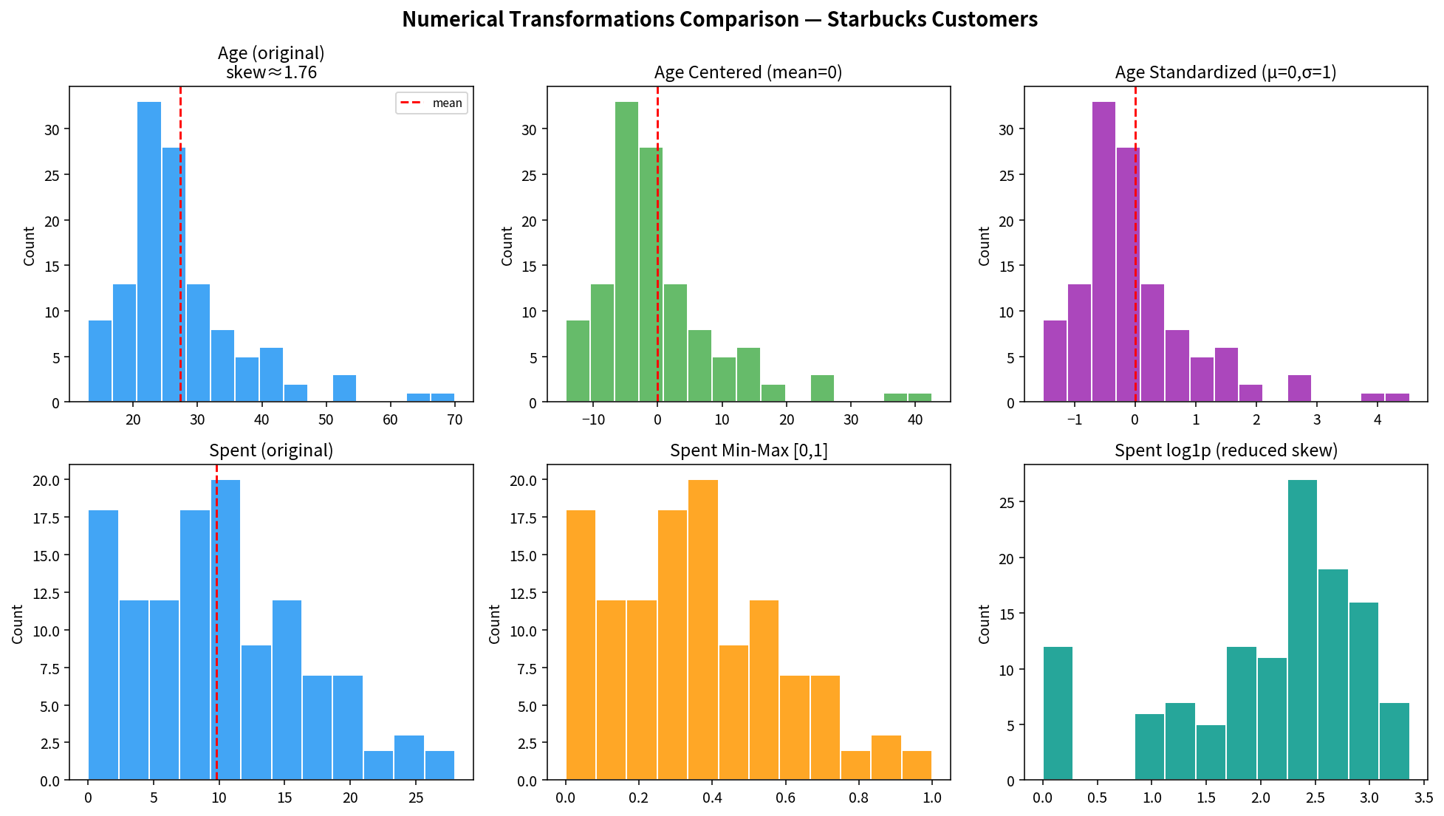
Audience notes: Data scientists / ML engineers receive full formulas + sklearn pipelines and the simulation. Business analysts / executives receive the before/after histograms and a one-sentence takeaway (“scaling + log transform improves model stability on customer spend predictors”). Nonspecialists see only the visual comparison and the plain-language “why” (make numbers comparable so the computer does not favour big numbers).
Key Takeaways
- Always diagnose scale and skew before modelling; histograms + .skew() are cheap insurance.
- StandardScaler (μ=0, σ=1) is the default for distance-based and regularized models; MinMaxScaler when the algorithm expects [0,1].
- Log (or log1p) is the simplest fix for right-skewed positive features and often improves linear-model fit.
- Centering alone is useful for interpretability of coefficients and residual analysis even when full standardization is not required.
- Simulation (bootstrap + noise) quantifies whether a transform actually helps on your particular data and sample size.
Extended project artefacts: Practice Skeleton + Solution notebooks, Cheatsheet, Flowchart, Reusable Template, simulation charts, data/starbucks_customers.csv

